**Shri Ramdeobaba College of Engineering and Management, Nagpur**

**Department of Electronics Engineering**

**Digital Image Processing (ENT 355-3)**

**Name:** Prajwal Pandurang Shette

**Roll No:** B1- 12

**Experiment No: 07**

**Aim**: a) Plot the Histogram of bright, dark, low contrast and high contrast images. Apply Histogram

equalization on these images.

b) Apply local image enhancement on an image using Histogram Processing.

c) Apply Histogram Statistics for enhancement of the image.

**Software Used:** Python, Jupyter, OpenCV

**Theory**: A histogram is basically used to represent data provided in a form of some groups.It is accurate method for the graphical representation of numerical data distribution.It is a type of bar plot where X-axis represents the bin ranges while Y-axis gives information about frequency. Histogram equalization is a method in image processing of contrast adjustment using the image’s histogram.

This method usually increases the global contrast of many images, especially when the usable data of the image is represented by close contrast values. Through this adjustment, the intensities can be better distributed on the histogram. This allows for areas of lower local contrast to gain a higher contrast. Histogram equalization accomplishes this by effectively spreading out the most frequent intensity values. The method is useful in images with backgrounds and foregrounds that are both bright or both dark.

**Code**

import cv2

from matplotlib import pyplot as plt

lowing = cv2.imread('image2.jpg',0)

# find frequency of pixels in range 0-255

low = cv2.calcHist([lowing], [0], None, [256],[0,256])

# show the plotting graph of an image

plt.subplot(4,2,1)

plt.imshow(lowing)

plt.subplot(4,2,2)

plt.plot(low)

plt.title('Low Contrast')

highing = cv2.imread('image1.jpg',0)

# find frequency of pixels in range 0-255

high = cv2.calcHist([highing], [0], None, [256],[0,256])

# show the plotting graph of an image

plt.subplot(4,2,3)

plt.imshow(highing)

plt.subplot(4,2,4)

plt.plot(high)

plt.title('High Contrast')

brighting = cv2.imread('img1.jpg',0)

# find frequency of pixels in range 0-255

bright = cv2.calcHist([brighting], [0],None, [256], [0,256])

# show the plotting graph of an image

plt.subplot(4,2,5)

plt.imshow(brighting)

plt.subplot(4,2,6)

plt.plot(bright)

plt.title('Bright Image')

darking = cv2.imread('Dark.png', 0)

# find frequency of pixels in range 0-255

dark = cv2.calcHist([darking], [0], None, [256], [0,256])

# show the plotting graph of an image

plt.subplot(4,2,7)

plt.imshow(darking)

plt.subplot(4,2,8)

plt.plot(dark)

plt.title('Dark Image')

plt.show()

**Output :**

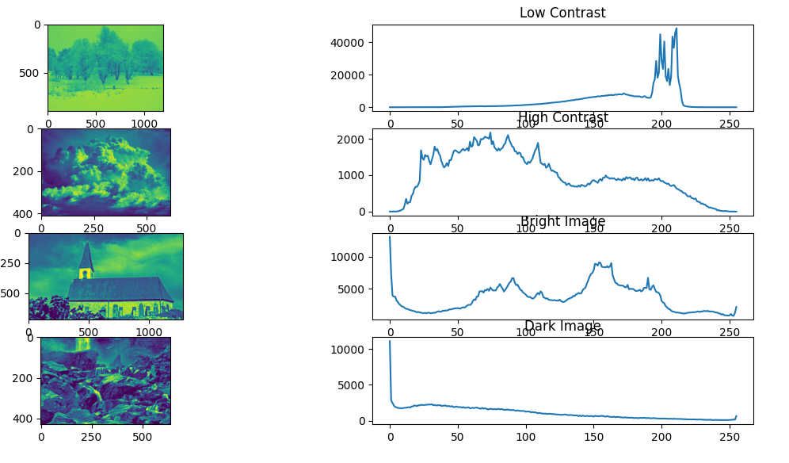

**Observation & Conclusion:** We saw how we can find histogram of an image. We can conclude that bright image have concentration of pixel values towards left whereas dark image has more concentration over right hand side. We also saw how histogram equalization can reduce the variance between the output images.